Rif. PA 2025-24397/RER - approvata dalla RER con DGR n° 1659/2025 del 20/10/2025 e co-finanziata dal FSE Plus 2021/2027

LANGUAGE TRAINING TO PROMOTE EMPLOYABILITY,
ADAPTABILITY AND INCLUSION

The proposed training offer is aimed at individuals who have completed compulsory education and the right-duty to education and training, regardless of their employment status, and who wish to undertake a learning path to improve their language skills. Participants must be residents or domiciled in the Emilia-Romagna Region prior to enrollment and must hold a valid residence permit.

The training offer is structured into the following courses:
❖ ITALIAN LANGUAGE – LEVEL A1, 80 HOURS
The A1 level course (beginner level) is designed for those with little to no knowledge of the language who wish to learn how to understand and use familiar everyday expressions and very basic phrases to meet concrete needs.
❖ ITALIAN LANGUAGE – LEVEL A2, 60 HOURS
The A2 level course (elementary level) is intended for those who already have a basic knowledge of Italian (A1) and can understand simple communication situations. The course strengthens both comprehension and oral/written production skills.
❖ ITALIAN LANGUAGE – LEVEL B1, 60 HOURS
The B1 level course (intermediate level) is aimed at those with an elementary knowledge of Italian (A2). It focuses on developing intermediate communication skills, enabling participants to manage everyday situations more effectively and to express experiences, opinions, and plans in greater detail.

Access to each course is subject to a structured entry test to assess the participant’s knowledge of Italian in accordance with the QCER reference level.
At the end of the courses, all participants will be given access to an exam leading to a certification of Italian language proficiency issued by an officially recognized certification body approved by the relevant Ministries.

Courses may be delivered either in person—at locations across the provinces of Piacenza, Parma, Reggio Emilia, Modena, Ferrara, Bologna, Ravenna, Rimini, and Cesena—or via live online sessions (synchronous videoconferencing). Upon specific request from one or more participants, in-person attendance at the designated training locations will be guaranteed.

The courses are completely free of charge, as they are approved by the Emilia-Romagna Region and co-funded by the European Social Fund Plus (ESF+) 2021–2027.

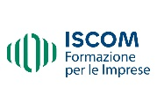



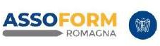
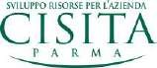
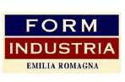
Per informazioni e iscrizioni: Claudia Sabbatini 0547639878 – coordinatore6@iscomcesena.it
